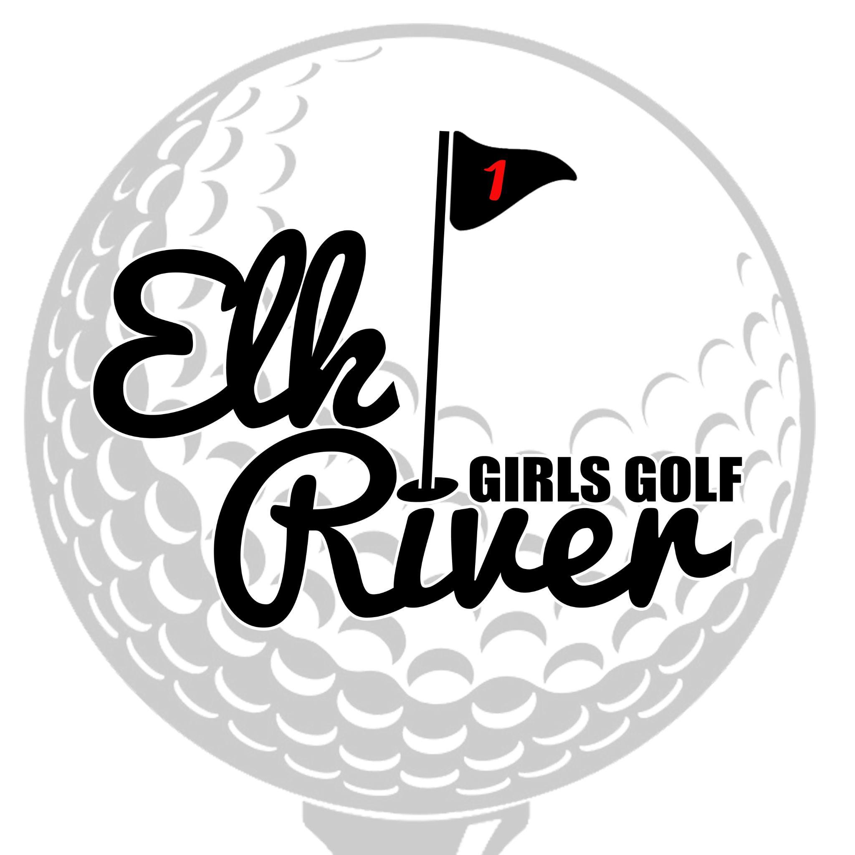
Elk River Girls Golf
Business Sponsorship
Elk River Girls Golf offers an opportunity to learn some of the basic skills of golf all while having fun and competing.
In order to run our program, we partner with local businesses to raise funds for needs that are not covered by ISD728. (off-season training, additional coaching, awards banquet, promotional materials, uniforms, supplies)
In return for your generous financial contribution and support, you or your business will receive the following:

LEVEL | Par  $100 | Birdie  $250 | Hole in One  $500
Logo Posted on ER Girls Golf Website | ✔ | ✔ | ✔
Group “Thank You” Sponsorship Post on ER Girls Golf Social Media Pages | ✔ | ✔ | ✔
Recognition at Women’s Clinic Fundraiser | ✔ | ✔ | ✔
Highlight Post on ER Girls Golf Social Media Pages |  | ✔ | ✔
Banner on ERGC Scoreboard throughout Golf Season (April-early June) |  |  | ✔

Please complete this portion & return with a payment to your player or mail to:
Elk River Girls Golf, PO Box 611, Elk River, MN 55330

Name of Sponsored Player: _______________________________________________

Name of Business: ___________________________________________________________
Business Contact & Phone Number: _______________________________________________

Sponsorship Level: PAR BIRDIE HOLE IN ONE OTHER

Total Amount: $________________ Payment method: Check Cash

(checks can be made out to ER Girls Golf)

Please email your logo to: elksgirlsgolf@gmail.com

THANK YOU IN ADVANCE FOR YOUR SPONSORSHIP & GO ELKS!

